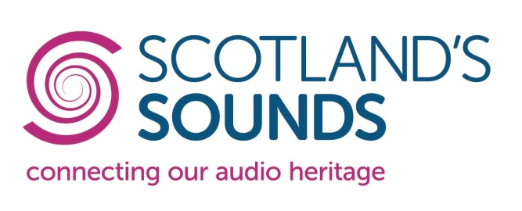
Researcher in Residence Programme

Hear Here: listening in to community sound archives

Host collection proposal form
Please read the terms and conditions attached before completing this form electronically and returning it by email to Amy McDonald (a.mcdonald@nls.uk).
The deadline for applications is midday on Wednesday 21 December 2016.

Your details
Name:
Job title (if applicable):
Name of Collection(s):
Organisation (if applicable):
Postal address of where the collection is held:
Email address:
Phone number:

Your proposal
Which sound recordings you would like a Researcher in Residence to explore? (please briefly describe the scale, genre, and subjects of the recordings involved)

How accessible would these recordings be to a Researcher in Residence (catalogued/listed, digitised etc).

What research/processing work would you like a Researcher in Residence to carry out (eg. appraisal, handling and storage, cataloguing, summarising, transcribing, digitising, writing a policy/plan, copyright/permissions research etc) Please note that no expenses can be paid for equipment or materials relating to this research/processing work.

How many days of a Researcher in Residence’s time would you estimate the work described above would take? How many of these would need to be on site where the collection is housed?

The Researcher in Residence would plan and deliver a public engagement activity as part of their residency – do you have any ideas about what you might like to see happen, or what audiences the Researcher in Residence could potentially engage with?

Please describe any public engagement activities you have delivered in the past related to your sound archives, if applicable.

What benefits would the overall project bring, if applicable, to the collection, your organisation, your staff, your volunteers and/or new audiences?

How would you plan to build on the results of this project once it comes to an end?

Thank you for sending this proposal to Amy McDonald at a.mcdonald@nls.uk by midday on Wednesday 21 December 2016.

Connecting Scotland’s Sounds is a project funded by the Esmée Fairbairn Foundation from 2016 to 2017 to champion the preservation and sharing of Scotland’s audio heritage.

